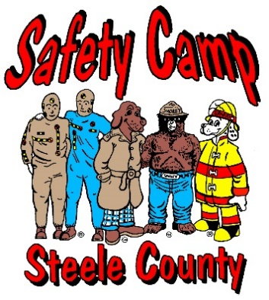

Steele County Safety Camp

*107 Main Street West*

*Owatonna, Minnesota 55060*

FOLLOW US ON FACEBOOK!!!! --- STEELE COUNTY KIDS SAFETY CAMP ---

Dear Parents:

**2023 Steele County Safety Camp is here!!!!** To register, visit the Park & Rec website and find the Safety Camp link. Registration deadline is May 31st. We have scholarships available if needed at the Owatonna Fire Department office. The scholarship is not available online so please go into the office at 107 W. Main St. Please give a valid email address, as that is where we will send you the information as to what team your child will be on.

On the first day, each participant will receive a T-shirt to be worn for both days of camp. They will also receive a backpack to use for their personal items during camp. If, for any reason, you need to pick up your child before the camp has finished for the day, you must let us know ahead of time. *Please note: the schedule you see attached/with the email is tentative with class times/events, however, registration/drop-off times will not change - 7:30-8:00 AM on both days.*

***\*NOTE: We are no longer grouping kids by school, they will be evenly distributed to teams randomly to control team size. Please see the email sent to you with what color team your child will be on.***

**Day 1 - June 8th – Kaplan’s Woods (Mosher Ave & 18th St SW)**

Bring your child to Kaplan’s Woods and park on Mosher or 18th Street SW. There will be camp staff to guide you to the registration area. At the end of the day, we will be busing all students to the Fairgrounds for pick up. We will have all teams in the Foundation Building. *In the event of inclement weather, we will have buses standing by to bus everyone to the Steele County Fairgrounds/4 Seasons. You may also listen to KRFO and/or KOWZ for updated information regarding the day’s events and you may also watch us on Facebook.*

**Items needed:**

* Any medication and instructions
* Swimsuit and towel – wear your swimsuit to camp under your clothes
* Please dress accordingly for the weather conditions
* Bag lunch if your child has any food allergies or does not like what we are serving

**Day 2 - June 9th - Steele County Fairgrounds – Foundation building (By Cattle Barns)**

Please drop your child off at *************. There will be camp staff to guide you to the registration area.

**Items needed:**

* Bike and helmet
* Any medication and instructions
* Please dress accordingly for the weather conditions
* Bag lunch if your child has any food allergies or does not like what we are serving

On June 9th at 4:00 PM, there will be a graduation ceremony followed by an ice cream social for all family members. This will be held in the grass area outside the Foundation Building. Please have your child picked up no later than 4:45 PM.

If you have any questions, please feel free to contact one of the committee members named below. Thank you again for participating in Steele County Safety Camp!

Matt Oeltjenbruns, Owatonna Police Dept. 774-7216

Leila Kath, Owatonna Fire Department 456-1150

Tony David, Steele County Sheriff’s Office 444-3864

Melissa Beaver, Mayo Clinic Ambulance 475-0128

Dan Peach, Blooming Prairie Police Dept. 583-7885

Jared Hendricks, Owatonna Public Utilities 446-5432

Ted Mittelstadt, DAIKIN Applied 451-7946

Lisa Boyd, Cybex | Life Fitness 414-4289

**Food Information**

* **Thursday, June 8th** 
  + Morning Snack: Apple or banana
  + Lunch: Pizza from Godfather’s (Cheese, pepperoni, and sausage)
* **Friday, June 9th** 
  + Morning Snack: Hy-Vee brand granola bars or fruit snacks
  + Lunch: Hy-Vee brand hot dogs and buns, Hy-Vee brand cookies, Lays chip assortment
  + Afternoon Snack: Bomb pops or alternative popsicle
  + Graduation: Vanilla or chocolate ice cream from The Blast

**Snack items may change due to availability. If your child has food allergies, please send an alternative and let the head counselor know at registration.**